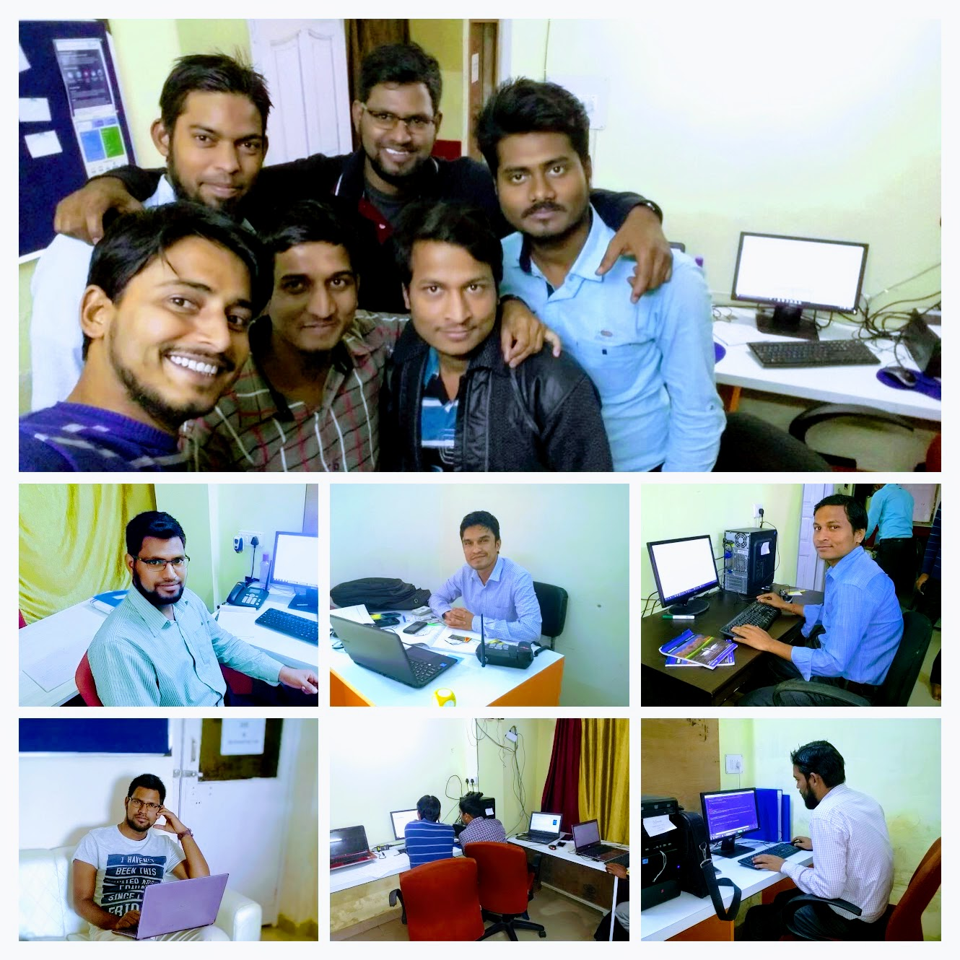

Kenspeckle Team (top)

Shahzeb Salim(MCA) - Tcehnical Lead, Syed Afzal(MBA) - Sales & Marketing Lead, Ritesh Kumar(B.Tech) - Web Designer, Shahzeb Salim - Tcehnical Lead, Abu Hasan(MCA) & Amit Kumar(B.Tech) - Mobile Apps Team,

Abdul Ali (MCA) - PHP and My SQL Developer (from left)